LAB211 Assignment | Type: | Short Assignment
 | Code: | J1.S.P0078
 | LOC: | 100
 | Slot(s): | 2

Title
Create a program to copy file
Background
NA
Program Specifications
Write a program with file config.properties
1. COPY_FOLDER=D:\\Data.
2. DATA_TYPE=*.CSV,*.WAV.
3. PATH=D:\\ Copy Data
When program run
If file config is not exist, prompt user to input file config with
- Enter Copy Folder:
- Enter Data Type:
- Enter Path:
After input, program create file config and perform next steps
If file config is existed, check file content for following cases
- COPY_FOLDER
  - Not input yet.
  - Path to source folder is not existed
- DATA_TYPE
  - Not input yet
- PATH
  - Not input yet
  - Input but not existed -> create a path.
If checking file config task has error, show error message and stop program
If file config completed then copy file config from COPY_FOLDER to PATH
Function details:
Function 1: Display a menu and ask users to select an option.
- Users run the program. The program prompts users to select an option.
- Users select an option, perform Function 2.
Function 2:
- If file config is not exist, prompt user to input config file with following format:
- Copy Folder:
- Data Type:
- Path:
Perform next steps with existed file
- If file existed
- Verify data in config file
- COPY_FOLDER
  - Not input yet
  - Path to source folder is not existed
- DATA_TYPE
  - Not input yet
- PATH
  - Not input yet
  - Input but not existed -> create a path.
- If checking file config task has error, show error message and stop program
- If file config completed then copy file config from COPY_FOLDER to PATH

Expectation of User interface:
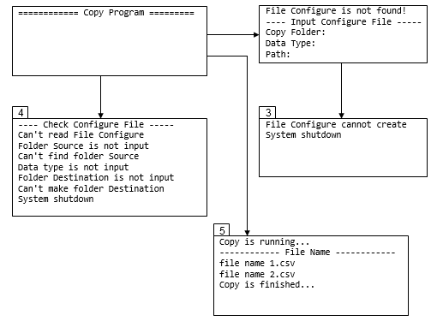

Guidelines

Student must implement methods
readFileConfig
createFileConfig
checkConfig
copyFile
in startup code.

Suggestion
Function 1: Read file config.proprties
- Implement function: public Config readFileConfig(Config config) throws ExceptionHandle
  - Input:
- config: Object contains configure information.
  - Return value
- Object config has been fill all information
- ExceptionHandle list.
Function 2: Create file config if not existed
- Implement function: public void createFileConfig(Config config) throws ExceptionHandle
  - Input:
- config: Object contains configure information input from keyboard.
  - Return value:
- ExceptionHandle list.
Function 3: Verify file config
- Implement function: public void checkConfig(Config config) throws ExceptionHandle
  - Input:
- config: Object contains configure information.
  - Return value
- ExceptionHandle list.
Function 4: Perform copy task if file config is valid
- Implement function: public List<String> copyFile(Config config)
  - Input:
- config: Object contains configure information.
  - Return value:
- List of files copied

